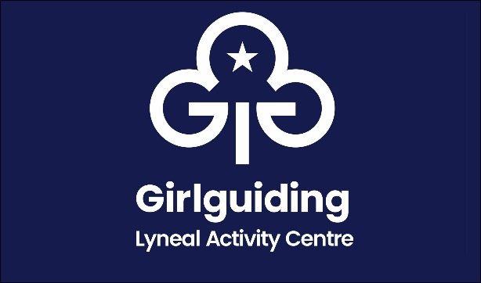
Booking Form 2025

Name of Group
Name of person in charge
Address
Phone number
Email
Purpose of visit
Date From |  | Arrival time
Date To |  | Departure time
Estimated total numbers attending

Please Tick
I confirm I have read and understand the booking information

I confirm that I need to pay for a minimum of 10 people per night
I confirm I have enclosed the non refundable deposit of £50
Cheque made payable to The Guide Association Shropshire
I confirm that I have made a bank transfer for the non refundable deposit of £50
The Guide Association Shropshire sort code 30 18 55 account 00724365
Please use your group name as your payment reference
I confirm that the final numbers and balance will be paid 21 days before the event

Signed
Date

This form to be completed and returned to:
Email: lyneal@girlguidingshropshire.org.uk
Mrs Mary Howard, 38 Wem Road, Shawbury, Shrewsbury SY4 4NW 01939 250741

