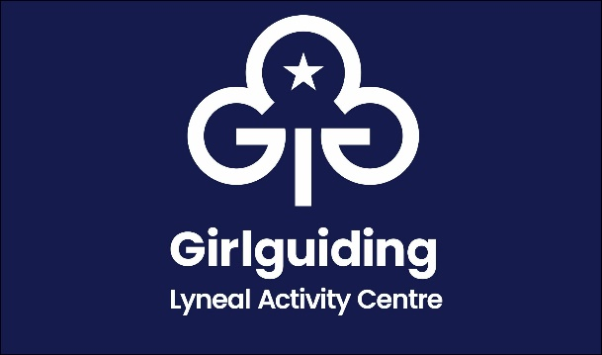

Booking Information

Conditions of Use

|  |  |  |
| --- | --- | --- |
|  | Guiding & Scouting | All Other |
| Per Person Per Night | £8.50 | £11.00 |
| Minimum Booking numbers | 10 people  £85.00 | 10 people  £110.00 |
| Non refundable deposit to secure booking | £50.00 | £50.00 |
| Balance to be paid with final figures 21 days prior to the event | | |

1. Bookings are not confirmed until you have received communication from the bookings secretary
2. You will also be given the code to the padlock on the gate and the key safe which is located by the back door. Please ensure keys and padlocks are returned upon exit
3. Users will be held responsible for the cost of making good any damage done to the premises including paintwork, furniture, or equipment at the discretion of the Lyneal Chairperson
4. Groups are asked to ensure each room plus toilets and showers are thoroughly cleaned before departure. Cleaning equipment and materials are provided in the main hallway
5. Residential accommodation is for a maximum of 24 people. We request users to wear ‘indoor’ shoes/ slippers in Lyneal Activity Centre
6. No responsibility can be accepted by The Guide Association Shropshire for injury, loss or damage to person or property while using the centre
7. Some activities and equipment have been provided for the use of visitors to the centre. Please ensure this is left neat and tidy upon exit
8. Please note that the bottom fitted sheets and pillow cases provided are for protective purposes and each visitor needs to bring their own bedding to use over the top in addition to these
9. Please ensure a fire drill is performed and that all users understand what to do in the event of an emergency
10. Please ensure all users understand how to operate the fire doors. Fire doors should remain closed, especially at night. Fire escape routes are displayed in red frames around the building
11. Mobile signal is poor at Lyneal and therefore the landline can be used for emergencies. The number is 01948 710668
12. A check list has been provided for you to complete upon entry and exit to ensure the centre is left at a suitable standard
13. Additional information such as booking availability, shop price list, resources and activities available and a sample risk assessment can be found on our website [www.lynealactivitycentre.org.uk](http://www.lynealactivitycentre.org.uk)
14. You will need to provide all personal use items such as first aid kit, towels, bin bags, food etc

To book or enquire, please contact our Booking Secretary

Email: [lyneal@girlguidingshropshire.org.uk](mailto:lyneal@girlguidingshropshire.org.uk)

Mrs Mary Howard, 38 Wem Road, Shawbury, Shrewsbury SY4 4NW 01939 250741