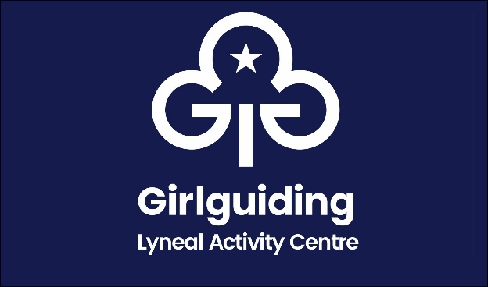
Hourly Booking Form

Name of Group
Name of person in charge
Address
Phone number
Email
Purpose of visit
Date of Hire |  | Number of hours  (min 2)
Arrival Time |  | Departure Time
Total Fee due (with a minimum of 2 hours)
£10 p/h Guides & Scouts
£12 p/h Other
Estimated total numbers attending

Please Tick
I confirm I have read and understand the booking information

I confirm I have enclosed the fee paid by cheque
Cheque made payable to The Guide Association Shropshire

I confirm that I have made a bank transfer for the fee
The Guide Association Shropshire sort code 30 18 55 account 00724365
Please use your group name as your payment reference

Signed
Date

This form to be completed and returned to:
Email: lyneal@girlguidingshropshire.org.uk
Mrs Mary Howard, 38 Wem Road, Shawbury, Shrewsbury SY4 4NW 01939 250741

